Steps to Set Up own MS Teams application on Azure.
- Go to https://portal.azure.com
- Click to App Registrations, Search (App Registrations) if already not visible
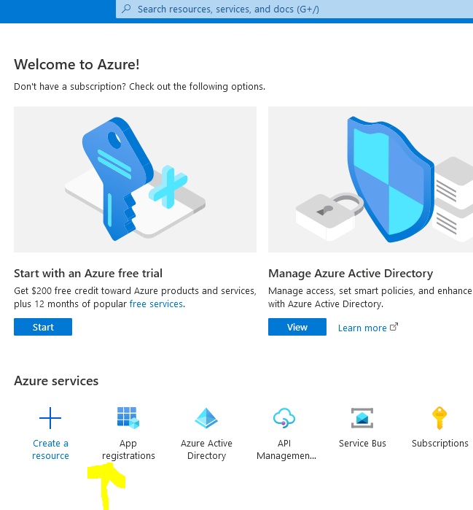
- Under new App Registration, Click on + button for New Registration
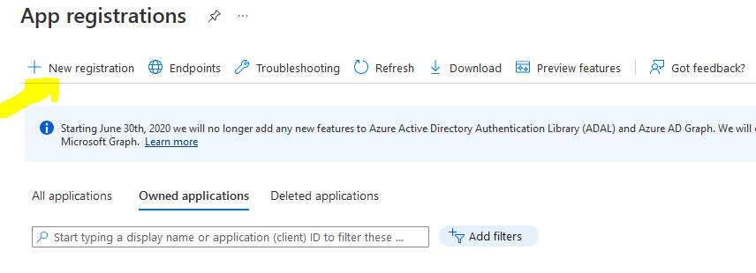
- Set Display Name , Supported preferred account type (You may Single tenant only) .Select Web under Platform and add following Redirect URIs
https://stage-talentech-recruiter.hr-manager.net/OnlineMeeting
https://talentech-recruiter.hr-manager.net/OnlineMeeting
https://localhost:44386/OnlineMeeting
- Configure following delegated permissions by Clicking MS Graph application
OnlineMeeting.ReadWrite
User.Read
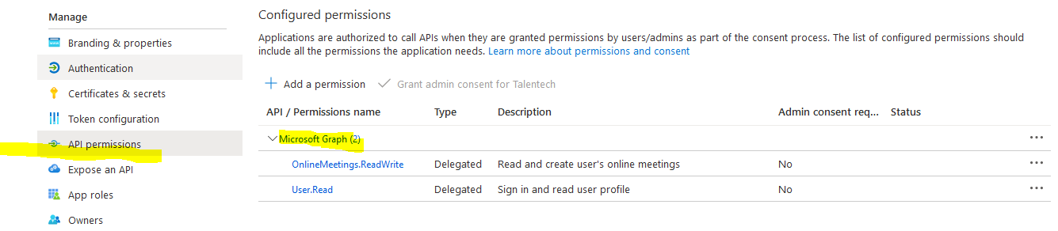

- Under Branding & Properties, Add MPN ID
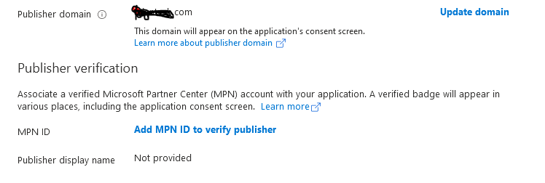
Click o Add MPN to verify publisher link to avoid UnVerified label in App
